TECHNICAL PROJECT REPORT

# Title: Sticker Display Board

# Team Members / Inventors:

|  |  |  |  |  |  |  |
| --- | --- | --- | --- | --- | --- | --- |
| **S. No.** |  | **Name** | **Department** | **Designation** | **Mobile** | **E-Mail** |
| 1. |  | Aatish Singh | CSE IBM BD | student | 9530220181 | Singham1308@gmail.com |
| 2. |  | Binayak Singh | CSE IBM BD | student | 6387728097 | Binayaksingh1999@gmail.com |
| 3. |  | X | X | X | X | X |
| 4. |  | X | X | X | X | X |
| 5. |  | Khushal Thakur | ECE | Mentor | 9646030764 | khushal.thakur@cumail.in |
| 6. |  | Anshul Sharma | ECE | Mentor | 9478697475 | anshulsharma.ece@cumail.in |
| 7. |  | Kiran Jot Singh | ECE | Mentor | 9463909689 | kiranjotsingh.ece@cumal.in |
| 8. |  | Divneet Singh Kapoor | ECE | Mentor | 9878422653 | divneet.ece@cumail.in |

Section – 1 (IPR Related)

# Brief Abstract (500 words):

# In the sticker display, we making this project for decoration in houses or workplace. this project will used on occasions like Diwali, Christmas, Id, and Many more FESTIVALS as well as the home decoration like photo framing in it, name of family members, any photograph of particular person or memories. The sticker display described here is built around the Arduino platform. The circuit is nothing but, multi-mode digital light controller, realised using very few external components. Six LEDs are made to glow in same sequences , controlled from the Arduino board by a switch. For this project, in addition to an Arduino UNO board, you need a USB cable (A to B), PC running the Arduino IDE, components (Six LEDs and 220-ohm resistors, a ohm resistor and a switch), accessories (wires, connectors and Power Bank), and the code or sketch in the proteus. In the prototype, six Blue LEDs are used at the output. However, the same output lines can also be used to control high-voltage incandescent lamp strings with the help of suitable solid-state light switch modules. A push-to-on switch is the one and only output mode selector in the circuit. The screenshot of Sticker Designing wiring generated using Proteus is shown. The table shows the function of switch and corresponding output on Led . WITH The Help of Windows and the Software, Double-click the folder to open it. There should be a few files and sub-folders inside. Make sure to maintain the automatic folder structure after download. Connect the Arduino board to your computer using the USB cable. The green power LED on the Arduino Uno board should glow. Wait for Windows to begin its driver installation process. After a few moments, the process will fail. Don’t worry! Just click ‘Start’ menu, and open up ‘Control Panel’. While in the control panel under ‘Category View’ option, navigate to ‘System and Security.’ Next, click ‘System.’ Once ‘System’ window is up, open ‘Device Manager.’ Look under ‘Ports’. You should see an open port named ‘Arduino UNO (COMxx).’ Right-click ‘Arduino UNO (COMxx)’ port and choose ‘Update Driver Software’ option. Next, choose ‘Browse my computer for driver software’ option. Finally, navigate to and select the Uno’s driver file ‘ArduinoUNO.inf,’ located in ‘Drivers’ folder of the Arduino software download. This completes the driver installation process of Windows.

# Existing state-of-the-art and Drawbacks in existing state-of-the-art

(*Brief background of the existing knowledge*)

|  |  |  |
| --- | --- | --- |
| **S. No.** | **Existing state of art** | **Drawbacks in existing state of art** |
| 1 | Sticker Display Board  https://github.com/binayaksingh99/beee-lab-project | Weak wood, short circuit |
| 2 |  |  |

# Novel/Additional modifications that you can propose to improve upon drawbacks

*(List down the features)*

* Attaching Led
* Working LCD for more better interface

# Advantages

(*List down the advantages, if each feature is incorporated)*

* decoration in any places
* compact take any where

# Block Diagram

(*Functional diagram depicting the flow of information in your system. Do not define exact components, only use generic terms. Must include modifications as well.)*

Glowing Slab

LED

Switch

ARDUNIO

Section – 2 (Real Project)

# Materials

(*List down the Components, Equipment, etc. actually used in the project*)

Wood (Rs.200)

Bread board (Rs.145.69)

Arduino (Rs.349.99)

Wires (Rs.50)

Led (Rs.60)

Button (Rs.10)

Glass slab (Rs.300)

Resistance (Rs.9.99)

# Circuit Diagram

(*Fully functional circuit diagram with exact connections. Can use Fritzing/Proteus*)

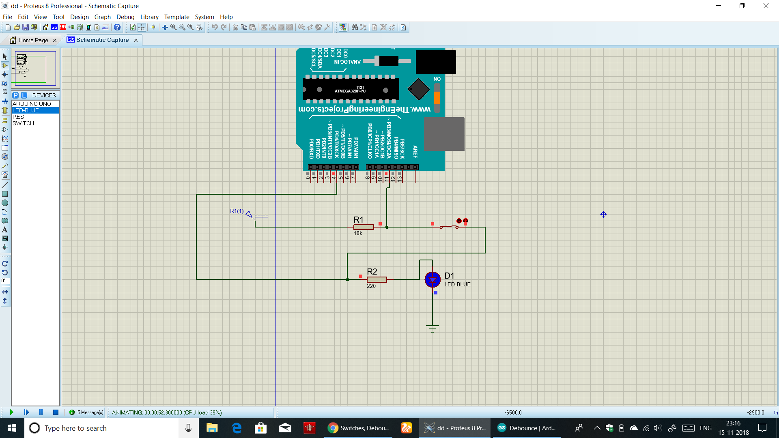

# Steps of Circuit Completion

(*Bifurcate the circuit completion in steps, specify with photographs, leading to final project*)

Cutting the wood desire shape(rectangular).

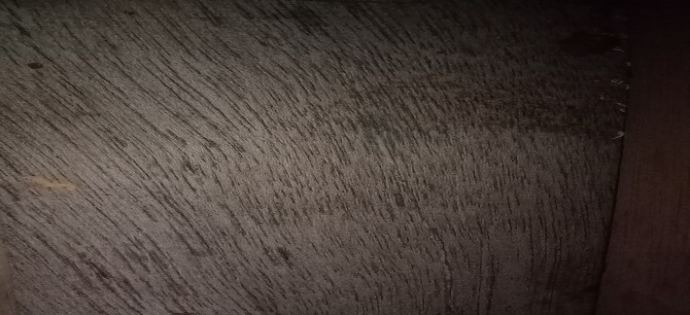

Making of rectangular box with the help of wood.

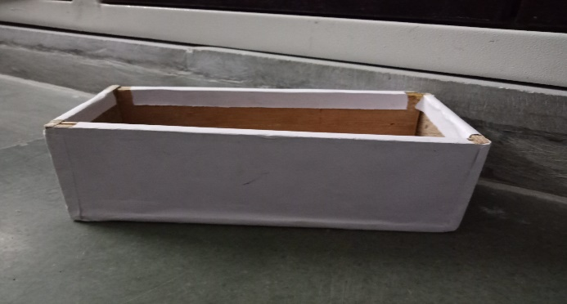

Placing the switch board at the base of wood and attach the Arduino.

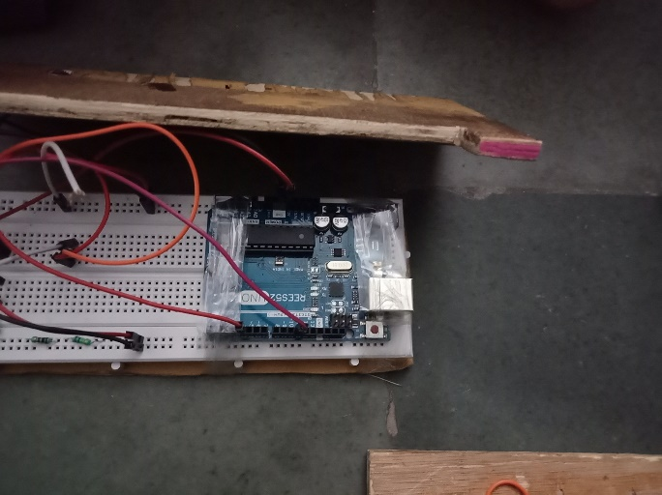

Connecting all the connection as per the circuit diagram.

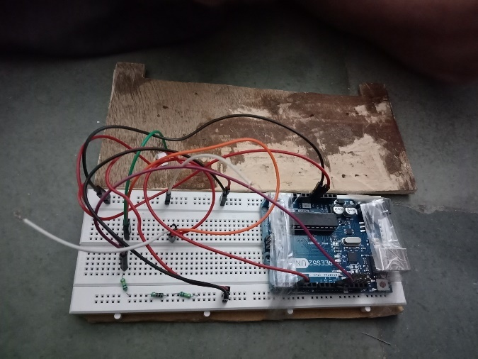

Putting the glass slab at the top.

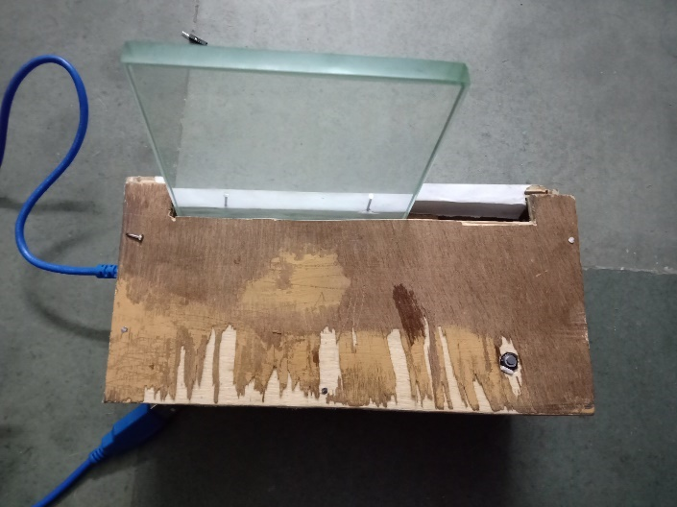

Sticking the sticker on glass slab.

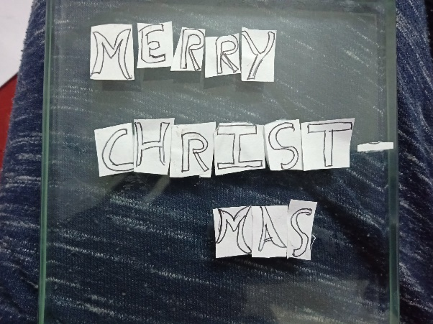

Decorating or final finishing on it.

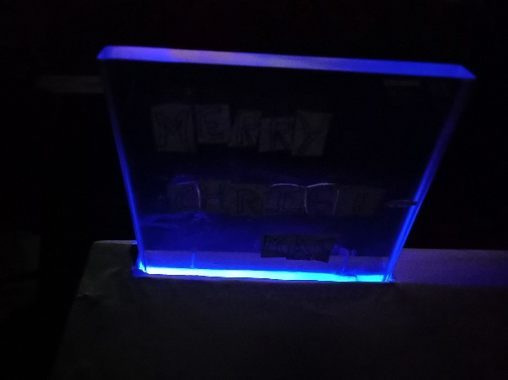

# Program Code

(*Link of your Github project*)

https://github.com/binayaksingh99/beee-lab-project